War is Hell
March 3rd, 2021

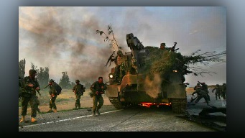
Lord Jesus, You are peace itself, and You have washed away our anger with Your precious blood. Because You love all men and women, help us to love our enemies and pray sincerely for them. Amen.

“How terrible Mother, please help me carry them in my heart. Especially those that are good trying to undo evil.”

“They don’t know Clare; they have fallen for the enemy’s narrative and so they are convinced. Yet in the end God will be glorified.”

“All the men, women and children who are innocent, there are so many, can’t a dispensation be given them?”

“When it comes to the innocent Clare, He is always merciful. But remember too that many, many cultures have embraced the video games and caused the children to fall into sin at a very early age. Yet Our God is merciful, so merciful and is longing to extend mercy.

“Pray for the hardened sinners, for the grace of contrition, so many have abandoned the faith and have nothing. Please do not grow weary in well doing, this is when the fate of thousands of souls will be decided. And how very painful it is for Our God to make these decisions, oh so painful. But if there is even a spark of repentance, He works with that. Make this day one of accelerated prayer for the world. So much is being decided and implemented even as we speak.

“So many things about this day have been pre-planned and are just now being set in motion. Your prayers are extremely important because they are saving lives and souls.”

I saw Our Lady weeping, she said, “It is beyond comprehension what people are suffering. This machine of “war” is animalistic and has no conscience when it sees people dying. It is taught to continue and follow through with brutality. This is their job, and this is why so much prayer is needed. “Untold anguish,” yes, that describes what is taking place. War is sheer Hell Beloved, sheer Hell. But try to remember, your prayers do bring comfort. Do not abandon prayer for them, press in. Be the faithful servant.”

